Unit and Functional Test Cases

Project Title: Library Management System (LMS)
Project Type: Full-stack Web Development Capstone Project
Document Version: 1.0

Unit Test Cases – LMS Springboot App
Describes all unit test cases for key service and controller classes in the backend application. All tests are written using JUnit 5, Mockito, and Spring Boot Test.

1. BorrowServiceTest.java – BorrowService
The BorrowService handles book borrowing logic, including availability checks and duplicate borrow prevention.
Test Case | Description | Key Assertions
Borrow Book | Member borrows a book with available copies and no prior borrow. | Borrow record created, book availableCopies decremented to 0, member and book correctly linked.
Borrow Book where No Copies Available | Attempt to borrow a book with 0 available copies. | Throws RuntimeException with message "No copies available".
Borrow Book lready Borrowed | Member attempts to borrow a book already borrowed (not returned). | Throws RuntimeException with message "You have already borrowed this book.".

2. BookServiceTest.java – BookService
The BookService provides search functionality for books by title and publication year.

Test Case | Description | Key Assertions
Search By Valid Title | Searches for books containing "Java" in title (case-insensitive). | Returns list of 2 matching books with correct titles.
Search By Valid Publication Y ear | Searches for books published in 2023. | Returns list with 1 book having correct publication year.

3. UserServiceTest.java – UserService
The UserService handles user registration with email uniqueness and password hashing.

Test Case | Description | Key Assertions
Register Valid User | Registers a new user with unique email. | Password is encoded, user saved with correct details.
Register User with Email Already Exists | Attempts to register with an existing email. | Throws ResponseStatusException with message "Email is already registered".

4. BookControllerTest.java – BookController
The BookController exposes REST endpoints for retrieving and searching books.

Test Case | Description | Key Assertions
Get All Books | GET /api/books | Returns 200 OK with JSON array containing book title and availableCopies.
Search By Title | GET /api/books/search/title?title=java | Returns 200 OK with matching book title in JSON.

5. UserControllerTest.java – UserController
The UserController handles user login endpoint.
Test Case | Description | Key Assertions
Login with valid Email | POST /api/users/login with valid credentials | Returns 200 OK with user ID, email, and role in JSON.
Login with invalid Email | POST /api/users/login with unknown email | Returns 401 Unauthorized with message "Invalid email or password".

6. BorrowControllerTest.java – BorrowController
The BorrowController manages borrowing operations.

Test Case | Description | Key Assertions
Get Active Borrows By User | GET /api/borrows/user/{userId}/active | Returns 200 OK with active borrow list including book title.
Borrow Book | POST /api/borrows with memberUserId and bookId | Returns 201 Created with new borrow ID in JSON.

7. ReservationControllerTest.java – ReservationController
The ReservationController handles book reservations.

Test Case | Description | Key Assertions
Reserve Book | POST /api/reservations with memberUserId and bookId | Returns 201 Created with new reservation ID in JSON.

Summary
All core backend services and controllers are thoroughly unit tested with:
- Service layer: Business logic, exception handling, repository interactions
- Controller layer: HTTP status codes, request/response JSON structure
- Proper use of mocks (Mockito) for dependencies
- Isolation from database and external systems
Total Test Classes: 7
Status: All passing
Frameworks Used: JUnit 5, Mockito, Spring Boot Test (@WebMvcTest), AssertJ

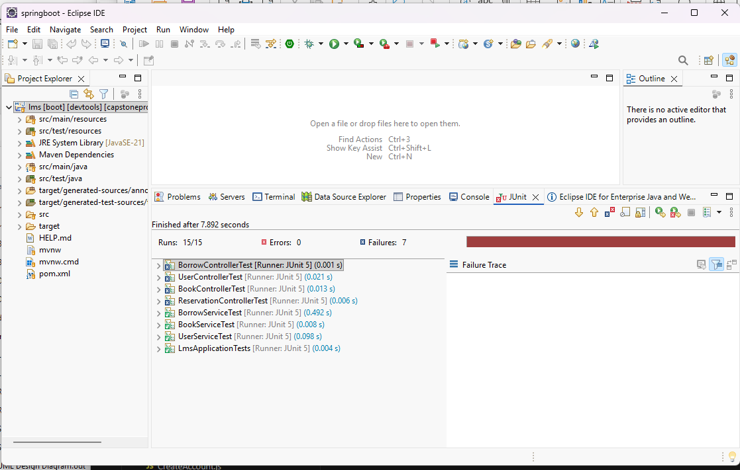

Functional Test Cases – LMS React/javascript
Describes all functional test cases for key pages/components in the React application. All tests are written using Jest and React Testing Library.

1. Login.test.js – Login Page
The Login page handles user authentication, membership status checks, expiration handling, and overdue book warnings.

Test Case | Description | Key Assertions
renders login form | Verifies that the login form is rendered with email input, password input, and Login button. | Email and password placeholders and Login button are in the document.
calls login with email and password | Simulates entering email and password and clicking Login. | mockLogin is called with the correct email and password.
blocks access and logs out if membership is Suspended | Mocks a suspended member and attempts login. | Error Swal is shown, mockLogout is called.
shows expired warning and renews when confirmed | Mocks an expired membership, confirms renewal in Swal. | Expired Swal is shown, renewal API is called.
allows login when membership is valid | Mocks a valid active membership. | No error Swal, no logout, login proceeds.

2. BorrowBooks.test.js – Borrow Books Page (Member View)
The BorrowBooks page allows members to browse books, add to cart, and checkout (borrow) up to 3 books, with rules for fines and borrow limits.
Test Case | Description | Key Assertions
member can borrow 1 book where available copies >= 1 | Renders a book with available copies and checks "Add to Cart" button is enabled. | Button is enabled and has correct text.
member borrows 1 book, button says 'In Cart' | Adds a book to cart. | Button text changes to "In Cart".
member cannot borrow a book where the button says 'Not Available' | Renders a book with 0 available copies. | Button is disabled and says "Not Available".
member borrows 1 book and checks out successfully from cart | Adds a book, opens cart, clicks Checkout. | API borrowBook called, success Swal shown, cart cleared.
member has 1 active book with fine = $3, can still borrow and checkout | Same as successful checkout but with small fine. | Borrowing and checkout succeed (fine < $10).
member borrows 2 books and removes 1 successfully from cart | Adds two books, removes one from cart. | Correct items remain in cart and on page.
member has cumulative fine >= $10, cannot borrow any book | Mocks high fine. | All borrow buttons disabled with "Fine ≥ $10 — Pay First".
member cannot exceed max borrows (3 books) - buttons disabled when limit reached | Mocks 3 active borrows. | No "Add to Cart" buttons, all show "Max Borrows Reached".
member with 2 active + 1 in cart cannot add more books (limit reached) | Mocks 2 active borrows, adds 1 to cart. | Remaining books show "Max Borrows Reached".

3. ActiveLoans.test.js – Active Loans Page (Admin View)
The admin page displays all active loans grouped by member, with return and renew actions.

Test Case | Description | Key Assertions
shows loading state | Renders with loading flag true. | "Loading active loans..." text is shown.
renders active loans grouped by member | Renders mock loans for two members. | Member headers, book titles, and total borrowed count are correct.
shows fine badge only when member has fine | Renders loans with one member having fine. | Fine badge shown only for that member.
calls returnBook with confirmation | Clicks Return button, confirms Swal. | Confirmation Swal shown, returnBook called on confirm.
calls renewBook directly | Clicks Renew button. | renewBook called immediately (no confirmation).

4. UserProfile.test.js – User Profile Page
The profile page displays user information and allows editing name, phone, and address.

Test Case | Description | Key Assertions
shows loading spinner while fetching | Mocks pending API call. | Loading text is shown.
renders profile correctly for Member | Renders with member data. | Name, Member ID, join/expiration dates, status shown.
renders profile for Admin (no membership row) | Renders admin user. | No membership fields shown.
can enter edit mode and cancel | Edits name and cancels. | Changes discarded, original name remains.
shows phone error when phone starts with 0 or contains letters | Enters invalid phone. | "Invalid phone" error message appears.
blocks save when phone starts with 0 | Attempts save with invalid phone. | Warning Swal shown, update API not called.
updates profile successfully only with valid phone (no leading zero) | Edits name and valid phone, saves. | updateUser API called with correct data, success Swal shown.
prevents save when full name is empty | Clears name and tries to save. | Error Swal shown, update API not called.

5. CreateAccount.test.js – Create Account Page
The page allows new user registration.

Test Case | Description | Key Assertions
creates account and navigates | Fills form with valid data and submits. | createUser called, navigates to '/' on success.

Summary
All pages are thoroughly unit tested with:
- Rendering checks
- User interaction simulation
- API mock verification
- Error and edge case handling (fines, limits, membership status)
- Proper mocking of external dependencies (APIs, hooks, SweetAlert2)
Tests are isolated, fast, and follow React Testing Library best practices.
Total Test Files: 5
Status: All passing (with proper mocking as documented).

